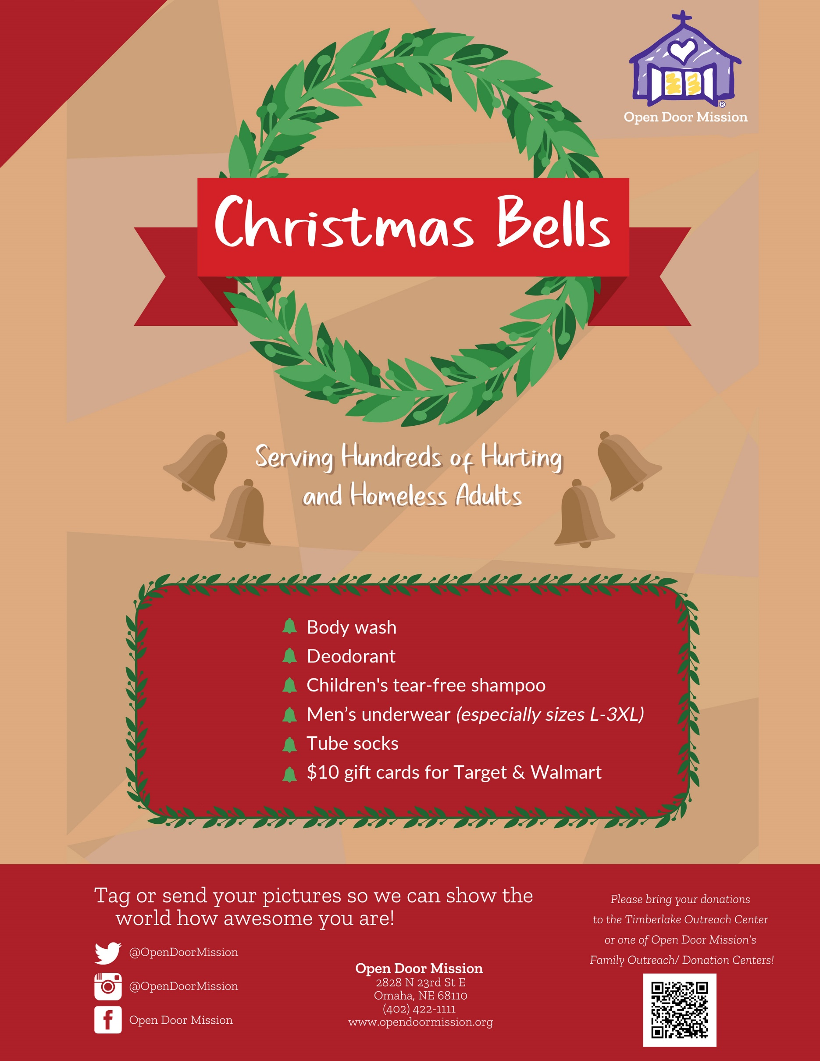

Drop Off Your Donation Items:

(Your Logo, Name, & Address or Location) on (Date/Dates)